**EC 9560 – DATA MINING**

**LAB 02**

**DARMILA.T**

**2020/E/027**

**SEMESTER 07**

**10th OCTOBER 2024**

**A comprehensive study on your data including data visualization, distribution analysis, correlation analysis.**

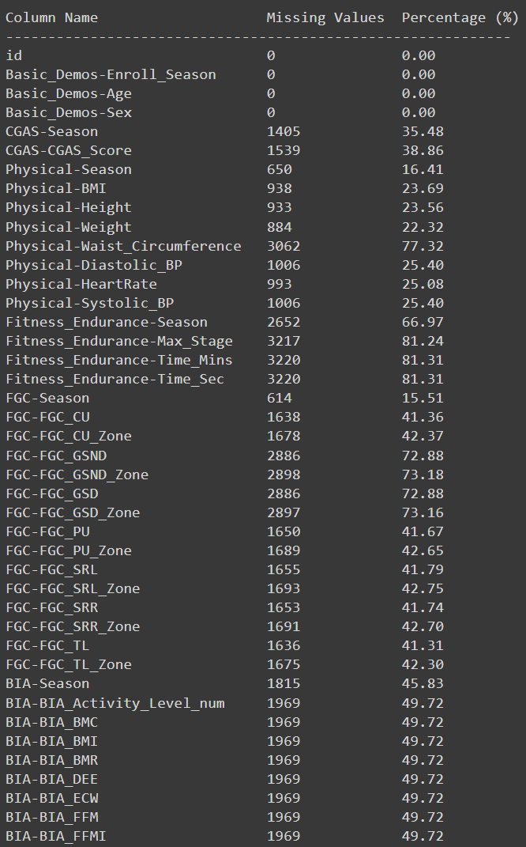The dataset have total 81 features. So first of all, I find the missing values count in the dataset.

Here, we can see most of the columns have much more null values because total there only 3960 samples.

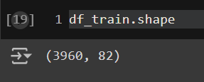

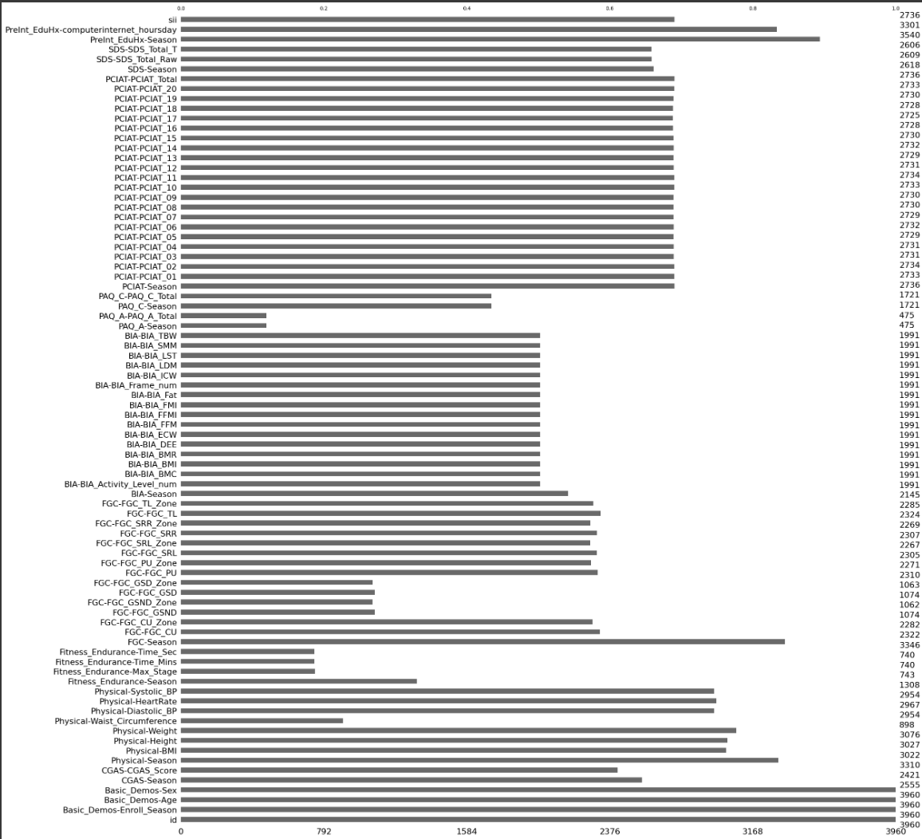

Total values of every features

Number of duplicates in the dataset

PCIAT Features:

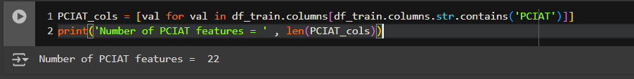

* As mentioned, there are 22 PCIAT features. These comprise answers to 20 questions (each marked out of 5), the total score and 'season' when the test was carried out.
* The sii target is derived from the total PCIAT score:
  + 0-30 gives sii = 0
  + 31-49 gives sii = 1
  + 50-79 gives sii = 2
  + 80-100 gives sii = 3.

This graph shows the outliers and category the target column sii.

Severity Impairment Index:

Here I plot when the sii = 0,1,2,3 for the PreInt_EduHx-computerinternet_hoursday

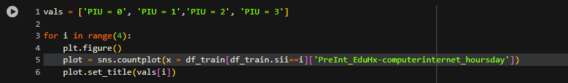

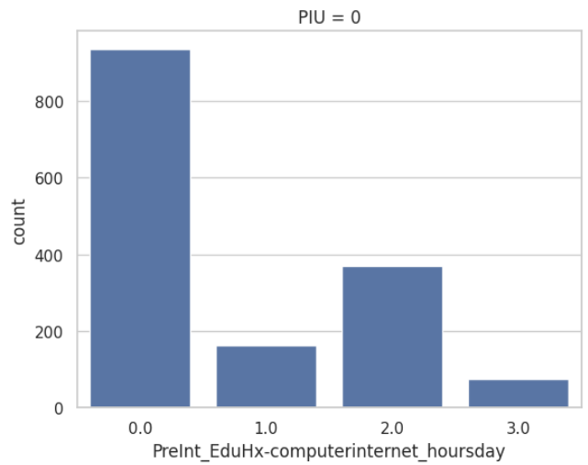

Correlation matrix

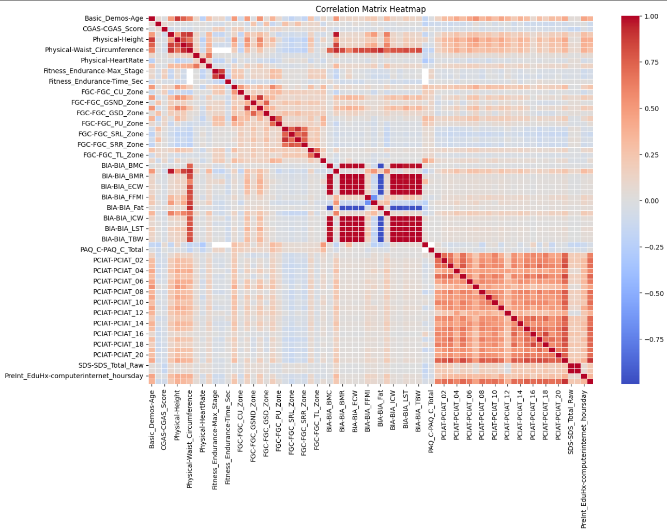

Based on this correlation find the maximum number of correlation pairs:

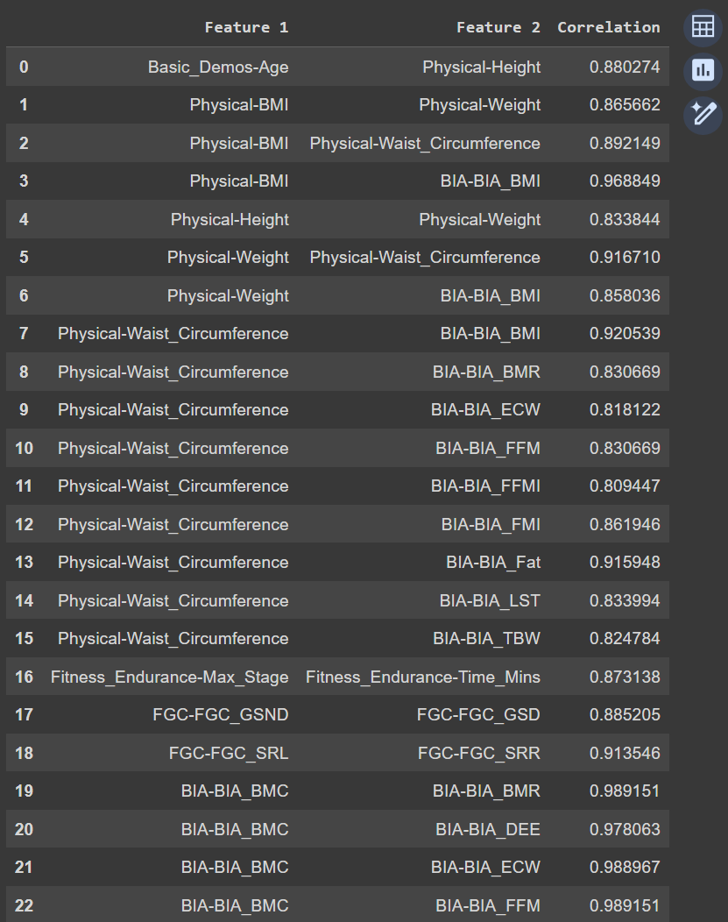

Based on this correlation,

I select these features based on the correlation with target more than 0.1 or less than 0.1

Find the features that are have the missing values more than the half of the data samples.  
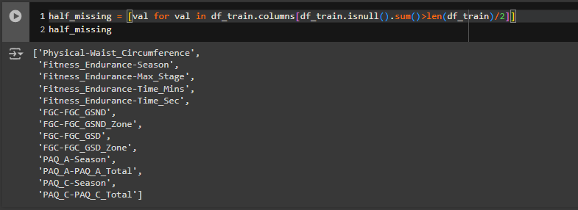

Then I checked is this features are selected above in selection matrix  


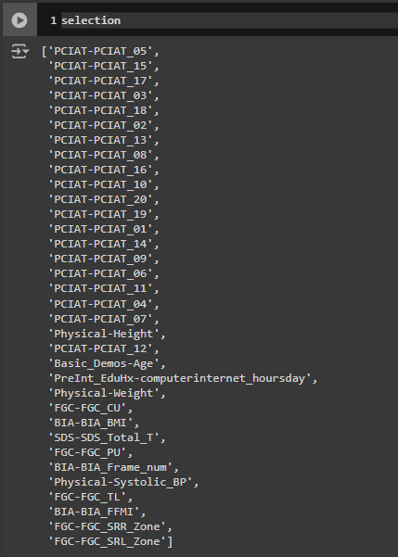

I now have 16 selected features based on a) correlation with the target and b) relatively few missing values.  


histograms for a selection of numerical features in a DataFrame named df_train

Visualization  
SII – Target  
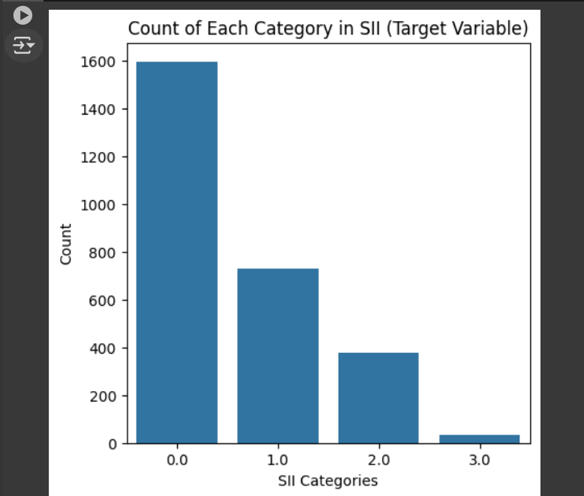

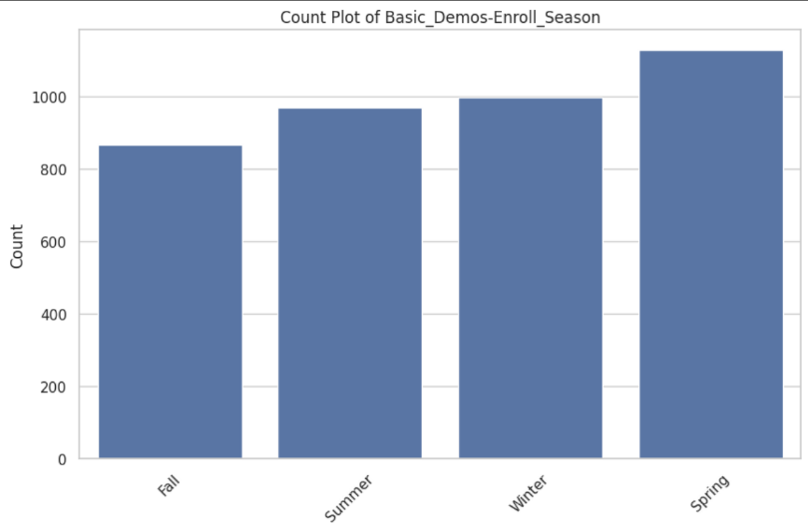

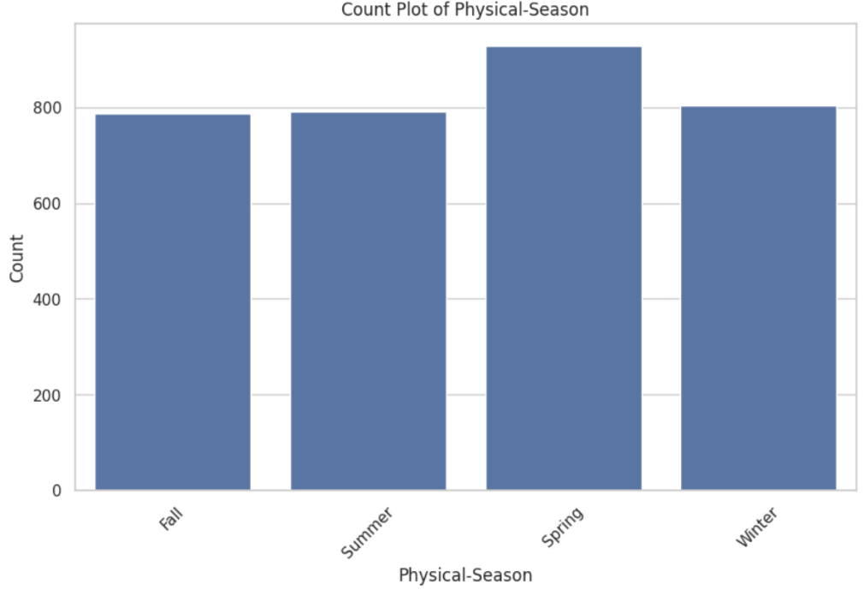

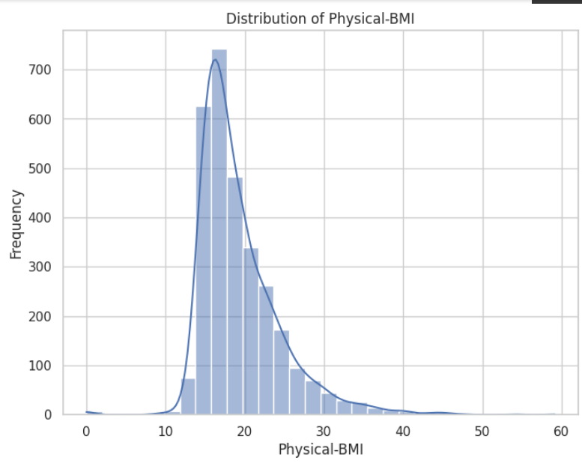  
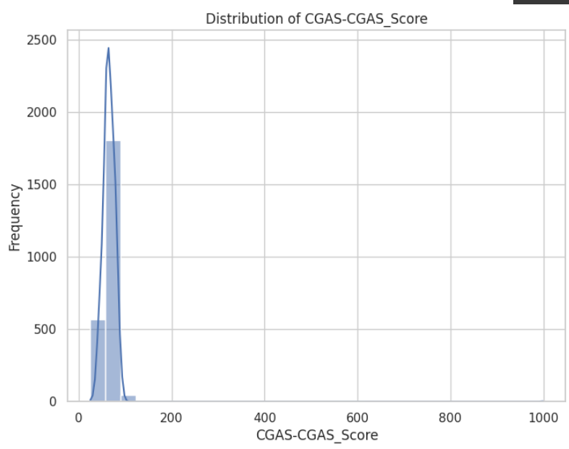

*# Set the style for seaborn*

sns.set(style="whitegrid")

*# List of categorical features*

categorical_features = [

    "Basic_Demos-Enroll_Season",

    "CGAS-Season",

    "Physical-Season"

]

*# List of numerical features*

numerical_features = [

    "Basic_Demos-Age",

    "Basic_Demos-Sex",

    "CGAS-CGAS_Score",

    "Physical-BMI"

]

*# Plotting categorical features*

for feature in categorical_features:

    plt.figure(figsize=(10, 6))

    sns.countplot(data=df_train, x=feature)

    plt.title(f'Count Plot of {feature}')

    plt.xlabel(feature)

    plt.ylabel('Count')

    plt.xticks(rotation=45)

    plt.show()

*# Plotting numerical features*

for feature in numerical_features:

    plt.figure(figsize=(8, 6))

*# Histogram*

    sns.histplot(df_train[feature], bins=30, kde=True)  *# Add kde=True for a kernel density estimate*

    plt.title(f'Distribution of {feature}')

    plt.xlabel(feature)

    plt.ylabel('Frequency')

    plt.show()

*# Box Plot*

    plt.figure(figsize=(8, 6))

    sns.boxplot(x=df_train[feature])

    plt.title(f'Box Plot of {feature}')

    plt.xlabel(feature)

    plt.show()

Here, I used bar chart and box plot for visualize the categorical and numerical values.

Summary Statistics



